

Final Report

|  |
| --- |
| School of Computing  Faculty of Engineering |

Procedural Modelling of Urban Cities

Nikolay Dimitrov Slavev

Submitted in accordance with the requirements for the degree of  
BSc Computer Science

**2018/2019**

**40 credits**

The candidate confirms that the following have been submitted*:*

|  |  |  |
| --- | --- | --- |
| **Items** | **Format** | **Recipient(s) and Date** |
| *Project Report* | *PDF* | *VLE (01/05/2019)* |
| *Project Report* | *Physical Copy (x2)* | *SSO (01/05/2019)* |
| *Source Code* | *Online Access (Appendix)* | *Supervisor, assessor (01/05/2019)* |
| *User Manual* | *PDF (in Appendix)* | *Client, supervisor (01/05/2019)* |
| *Video Demo* | *Online Access (Appendix)* | *YouTube (01/05/2019)* |

Type of Project: Exploratory Software

The candidate confirms that the work submitted is their own and the appropriate credit has been given where reference has been made to the work of others.

I understand that failure to attribute material which is obtained from another source may be considered as plagiarism.

Signed By:

© 2019 The University of Leeds and Nikolay Dimitrov Slavev

# Summary

Procedural modelling is a category encompassing a number of techniques for 3D modelling and texturing following a set of rules in computer graphics. That way, unlike all other modelling techniques which at some point require algorithms for data management and storage as well as model editing via user inputs, a rule set aims to provide the necessary requirements to create a model. Thus, a great amount of complexity, intricacy and believability can be achieved through implementation of simple rules if object patterns are analysed correctly. This is often the case when it would be too cumbersome to create models like architecture, plants and landscapes with generic modelling tools.

In this paper, we address the architectural modelling approach and more specifically the urban city problems in computer graphics. Every urban area poses a number of challenges encompassing population density, environmental influences, building aesthetics and street transport modalities for which adequative planning is essential and requires data [cityEngine]. Doing all of that manually leads to error-prone, costly and time-consuming development. On the other hand, complete modelling automation still remains a challenge due to the diversity, size and scale of the details required. Following hypothesis and algorithms cannot fully predict cases of historic and cultural street objects as well as junctions and buildings. As a result, the aim of this project is directed towards a procedural modelling of virtual cities attempting to combine the benefits as well as rectify the drawbacks of both manual and automatic generation. Users would be able to start and later edit a randomly generated or already existing street network as well as interact with a real geographic street map of their liking. That way, the clumsy manual modelling and the risk of fully relying on automatic generation would be reduced. Such software would benefit industries in the field of geodesign, urban planning, game development and film production.

# Acknowledgements

Tom Kelly – supervisor, fully supported me, answered any questions I had, great at quickly and effectively explaining difficult concepts, taught me ?, guided me through the ?, always positive, knew how to motivate by outlining the benefits of the project and how it could be expanded in the future

Hamish – helped me choose the most appropriate project for my skills and the one I would enjoy the most

ReadOSM

*<This page should contain any acknowledgements to those who have assisted with your work. Where you have worked as part of a team, you should, where appropriate, reference to any contribution made by others to the project.*

*Note that it is not acceptable to solicit assistance on ‘proof reading’ which is defined as “the systematic checking and identification of errors in spelling, punctuation, grammar and sentence construction, formatting and layout in the text”; see* [*http://www.leeds.acuk/qat/documents/policy/Proof-reading-policy.pdf*](http://www.leeds.acuk/qat/documents/policy/Proof-reading-policy.pdf)*. >*

# Table of Contents

Summary iii

Acknowledgements iv

Table of Contents v

Chapter 1 Introduction 1

1.1 Context 1

1.2 Problem Statement 1

1.3 Goal 1

1.4 Objectives 1

1.5 Plan 1

1.6 Methodology 1

Chapter 2 Background Research 2

2.1 Input Layout 2

2.2 Streets 2

2.3 Junctions 2

2.4 Building Parcels 2

2.5 Subdivided Parcels 2

2.6 Buildings 2

Chapter 3 Planning and Methodology 2

3.1 Initial Plan 2

3.2 Methodology 2

3.3 Risk Assessment and Mitigation? 2

Chapter 4 Implementation 2

4.1 Input Layout 2

4.2 Streets 2

4.3 Junctions 2

4.4 Building Parcels 2

4.5 Subdivided Parcels 2

4.6 Buildings 2

4.6 Exporting 2

4.7 Camera 2

4.8 Editing 2

List of References 3

Appendix A External Materials 4

A.1 Level 2 Heading with ‘heading 2’ Style Applied by Pressing Ctrl Shift 2 4

A.1.1 Level 3 Heading with ‘heading 3’ Style Applied by Pressing Ctrl Shift 3 4

A.1.1.1 Level 4 Heading with ‘heading 4’ Style Applied by Pressing Ctrl Shift 4 4

# Chapter 1 Introduction

## 1.1 Context

Modelling and visualisation of large and complex systems such as cities is a great challenge in computer graphics. As technology constantly improves and computing power increases, competing industries strive for more detailed, scaled and realistic visualisations. Most of the media, games, films, advertisement and television keep relying on the traditional approach of increasing the working load to meet their large project expectations. Those additional resources increase the cost and time which could be allocated to researching innovative features and improving the content’s creation. Such resources could be spent on manually modelling the details of large urban environments resulting in error-prone, costly, repetitive and time consuming activities while precisely attempting to satisfy every detail of the nowadays compelling models[review]. An automated solution to large-scale city generation is a procedural modelling technique [Parish and Muller ¨ 2001; Wonka et al. 2003; Muller ¨ et al. 2006] that uses simple rule set repetitively based on hypothesis and algorithms to make assumptions and predictions on how a model is created.

Creating large urban models require knowledge of different man-made systems with streets and buildings being the most essential ones. That said, according to Parish and Muller ¨ [2001], street networks are the key to creating such models[tensor]. L-systems are an approach where starting from a single street, more street segments can be added procedurally to form a street network [Prusinkiewicz and Lindenmayer 1991] [Prusinkiewicz et al. 2003]. That approach has been highly adopted and used as a basis of many procedural modelling improvement attempts trying to overcome an outcome limitation which results in unpredictable outputs that doesn’t match user expectations. Many research papers have added additional user-control support targeting that issue by providing guidance to the generation in the form of land-water boundaries, population density, aerial and tensor fields imagery. Moreover, streets could have many properties one of which is curvature and the Manhattan hypothesis where a city is organised along three dominant orthogonal directions could not be adopted [Coughlan and Yuille (1999)].

Procedural generation of parcels is the next key component for creating a complete urban modelling pipeline which generation includes several major consecutive steps after the underlying terrain is present and the road network created.

The steps are:

- divide the space in between the roads into blocks

- divide the blocks into lots representing the boundary space a building occupies

- populate the lots with buildings or other urban structures

The modeling and visualization of large-area cities using computers has become feasible with the large memory, processing and graphics power of todays hardware. [cityEngine]

## 1.2 Problem Statement

Procedural modelling on an architecture scale can be adopted to meet a variety of scenarios most of which continue to be a challenge. Starting from the use of GIS data for the precise depiction of the 3D world’s urban architecture to the development of random urban simulations, industries continue striving for the latest and most effective solutions. This paper tackles the challenge of modelling diverse urban environments of high complexity based on a hierarchical set of rules. Such environments can benefit projects where rapid development of large scenes is required. In the today’s world where scalability and complexity is a common necessity, doing everything manually requires large human labour introducing error-prone, costly and time consuming development that puts a barrier not only on established businesses but also on new fledgling companies trying to foothold into the market with their innovative solutions. Providing automation has been and continues being of high interest to companies and research facilities. A solution to that, addressed in this paper, is provided by fascinating techniques like L-Systems, fractals and generative modelling which make it possible to construct large scenes from small amount of rules where repetitive algorithm outputs does not need to be stored providing database amplification.

## 1.3 Goal

The project’s aim is to produce a procedural approach of city modelling that is primarily focused on street generation and secondarily on building’s architecture. This project will develop an exploratory software capable of automatically creating large 3D architectural scenes that rely on efficient rules and algorithms. To increase the user experience, diverse input options will be provided as well as a real-time editing functionality.

## 1.4 Objectives

In order to provide a thorough solution, milestones outline key project phases. These objectives are consecutively ordered representing the most common flow of procedural city modelling.

• Identify and select multiple ways of generating the street network (e.g. randomly, geographic data, existing file)

• Choose efficient technique for converting the network edges into street segments. Edges could be linear, quadratic or cubic Bezier curves with or without support nodes.

• Identify and implement an efficient algorithm to iterate over the network nodes and generate junction objects with respect to the intersection of edges and their joining point.

• Based on the street network solution, research and implement a technique for finding enclosed loops that will act as building parcels

• Considering the junction and street objects, implement a way that will store the building parcels without overlapping other objects.

• Find an algorithm which effectively divides the parcels into smaller blocks which will represent the allocated space of each building model

• Implement a simple rule for generating random buildings on every subdivided block

• Add a camera that can be rotated in any direction, zoomed in and out as well as moved forward and backward

• Add a real-time feature that enables adjustments to the street network

• Include an option that would export the model and make it ready for visualisation on other software products such as Blender and Sketchfab

## 1.5 Plan

Figure 1.1 shows a Gantt Chart of the overall project’s plan. The plan is very high level and only includes large topics which are necessary to meet the project’s deliverables criteria. It has an optimistic time scale with an expected end of coding implementations a month before the deadline. That is due to the intensity of other module materials expected to be delivered at the same time as the project. The last month would, therefore, be focused on lower risk tasks such as finalising the report and adjusting any minor inconsistencies.

|  |  |  |  |  |  |  |  |  |
| --- | --- | --- | --- | --- | --- | --- | --- | --- |
|  | Sept | Oct | Nov | Dec | Jan | Feb | Mar | Apr |
| Scope and Planning |  |  |  |  |  |  |  |  |
| Literature Review |  |  |  |  |  |  |  |  |
| Technology Review |  |  |  |  |  |  |  |  |
| Intermediate Report Writing |  |  |  |  |  |  |  |  |
| In-depth Research |  |  |  |  |  |  |  |  |
| Implement Model |  |  |  |  |  |  |  |  |
| Report Writing |  |  |  |  |  |  |  |  |

*Figure 1.1: Gantt Chart of the project’s plan*

## 1.6 Methodology

The exploratory nature of the project comes with a lot of uncertainty from which follows that changes might occur on a daily basis. A methodology known for its capability of adapting to change in a short-cycled manner is Agile. Therefore, the project’s development lifecycle will be based on it.

Each Sprint, which is a short Agile recursive timeframe, will not only involve development activities but also research ones due to my novel knowledge about the topic.

# Chapter 2 Background Research

The chapter is focused on examining industry and academic research papers that look into the identification and implementation of techniques applicable to the procedural modelling of urban cities.

A complete city encompasses an enormous number of elements with different structure, attributes and complexity. M. Wegner, however, split the urban model into subsystems and noted that networks, land use and housing were among the slowest changing elements (M. Wegner, 1988). Later, Parish and Muller identified the street network as the key subsystem to creating an urban city (Parish and Muller, 2001). Considering those findings, the paper would, therefore, only analyse the most irreplaceable and essential elements – street network and buildings. The former would be more substantial and thoroughly examined due to its key role in the development. That type of city generation can be achieved through a number of techniques addressing the creation of roads, lots and building structures (review).

The background research would examine the various procedural modelling techniques and provide further context to the project. It would measure the feasibility of the different algorithms as well as provide understanding of issues that might arise. After that, adequate planning, methodology and risk mitigations can be decided.

## 2.1 Street Network Layout

Fractals, L-Systems, Perlin Noise, Tiling and Voronoi are procedural methods which have been largely applied to natural objects and textures. Researchers, however, discovered that such methods can also be applicable to many other sectors one of which being the architecture of urban cities (review). This section, therefore, reviews and evaluates the various procedural techniques that researchers managed to adapt to the context of urban city areas.

revealing of patterns [cityEngine]

Grammar-based generation of models (especially L-systems) are employed in computer graphics mainly to create plant geometry [26]. L-systems have evolved into very sophisticated and powerful tools [20, 27] and have been extensively used in the modeling of plant ecosystems described in [8]. [cityEngine]

Procedural techniques have been applied successfully in the generation of numerous complex phenomena in computer graphics and have proved beneficial for a number of reasons

### 2.1.1 Extended L-System

Originally, the L-System was developed to model the growth and development behaviour of plants and later of various organisms. The theory behind it consists of alphabet symbols able to make strings. Those symbols get influenced by a collection of production rules which expand each symbol into large strings and with a special mechanism get translated into geometric structures. Aristid Lindenmayer defined that technique in the form of a formal grammar depicted as:

***G = (V, ω, P)***

where

V – is the alphabet defined by a set of symbols

ω – is the axiom (start position) represented as a string of symbols defining the initial state

P – is the set of production rules specifying the way variables can be recursively replaced to generate new symbol sequences

*Simple Example:*

variables : A B

constants : none

axiom : A

rules : (A → AB), (B → A)

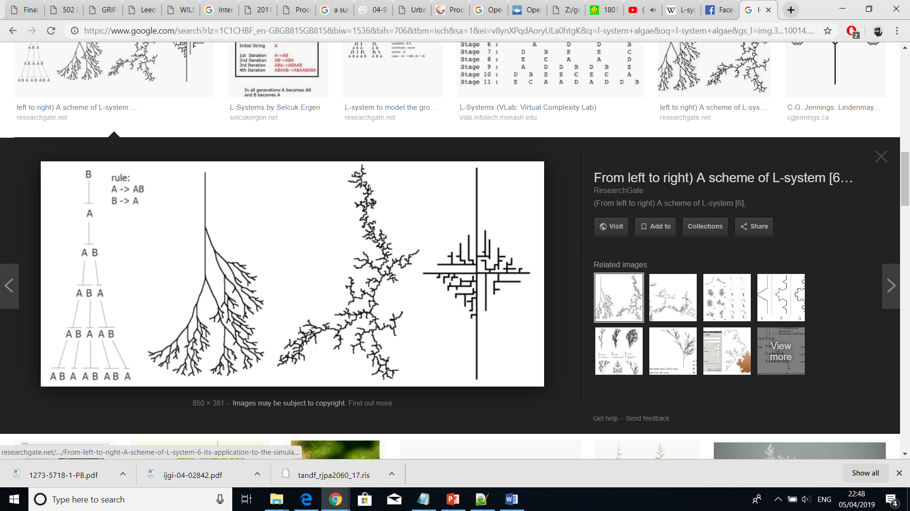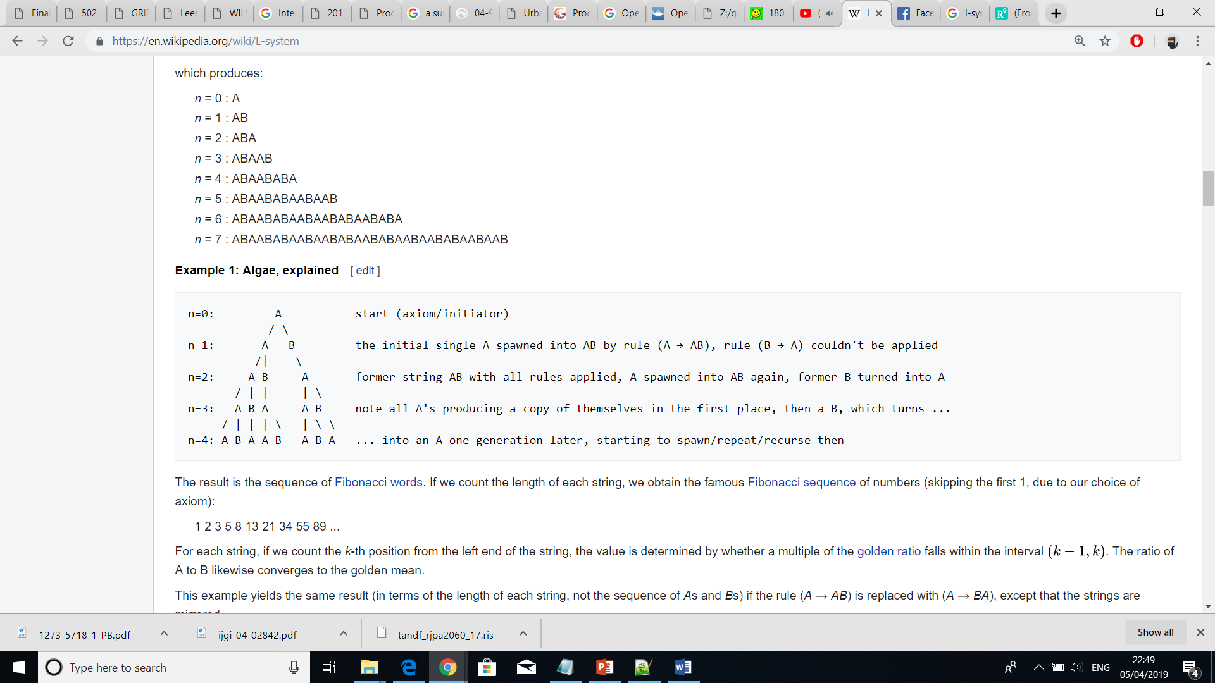

Parish and Muller extended the L-System with the aim of applying it to a street network. The extended version had the additional feature of forming loops where intersecting branches were present. That changed the topology and turned the tree-like structure into a netlike one.

*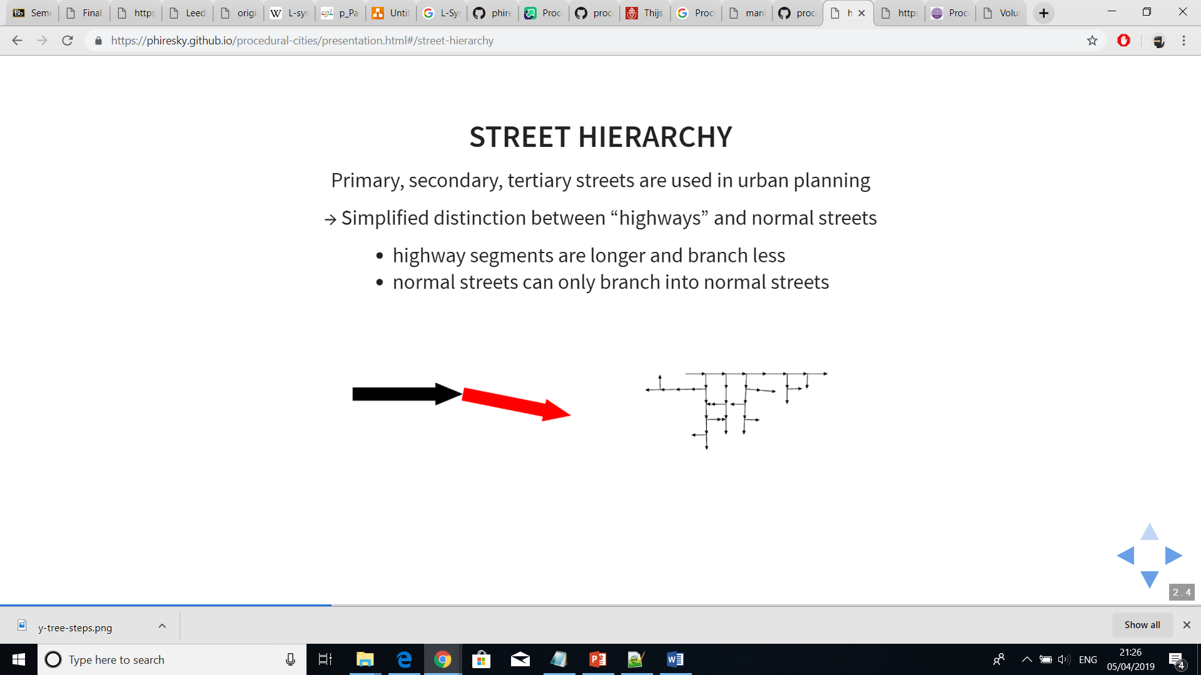Example of L-System with loops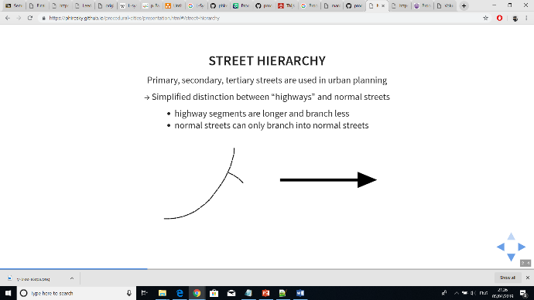*

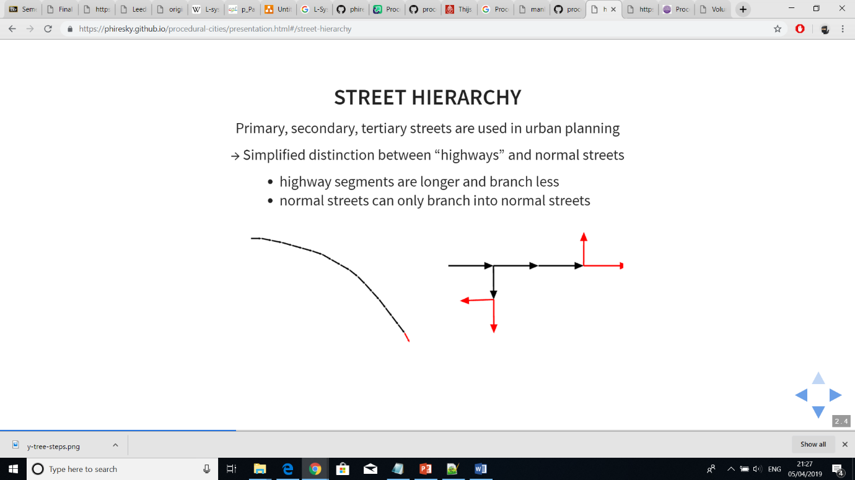

Additionally, the set of production rules got represented by Global Goals and Local Constraints.

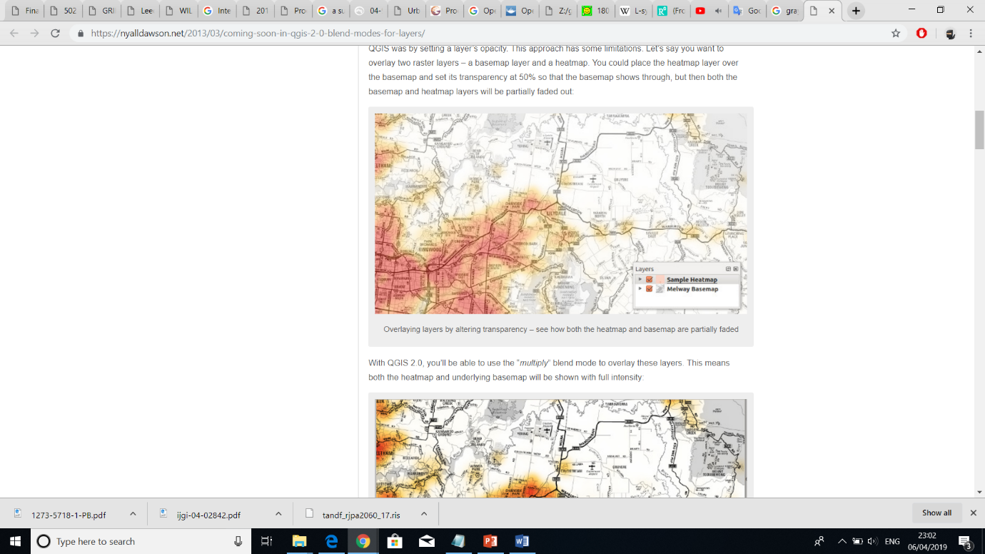Global Goals – can define road style, population density, elevation, land & water boundaries and zone types

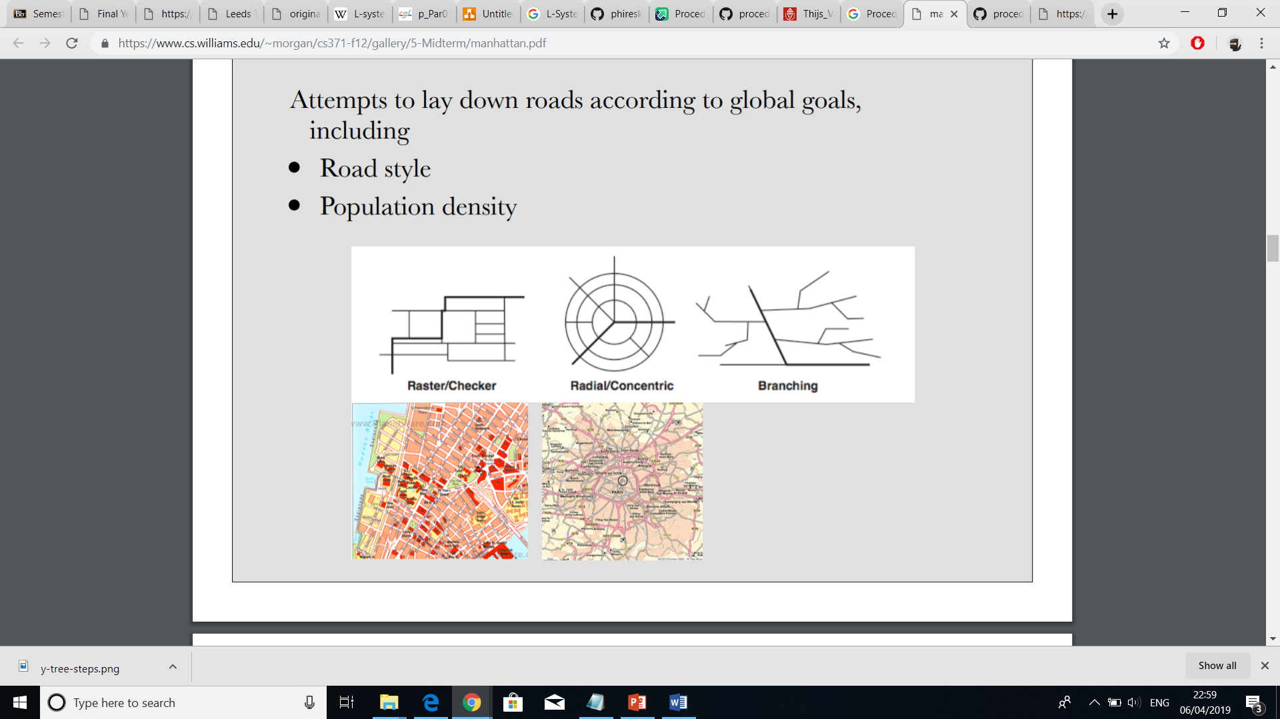

Local Constraints - prevent roads from crossing water and entering parks as well as modify road endpoints based on intersections with other roads within a given radius.

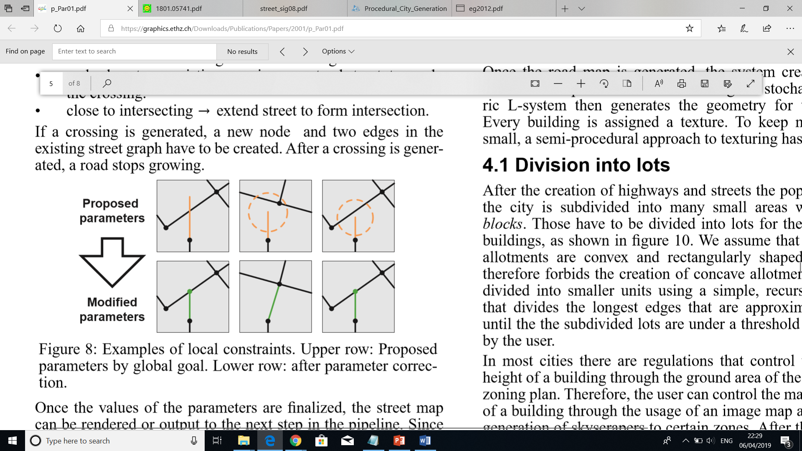

Example after applying global and local constraints considering highways and normal streets

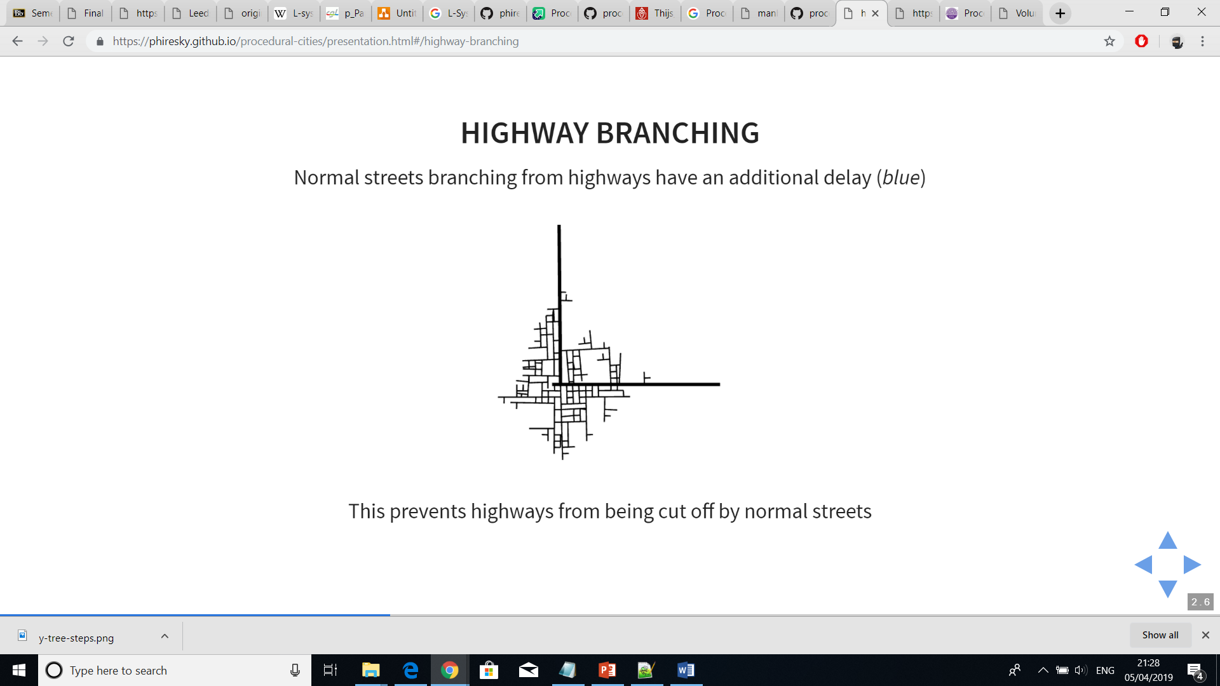

Road Patterns – Basic, New York, Paris, San Francisco – follow population density; follow angle and maximal length and width of a single block, all highways and streets form a rectangular blocks; highways follow radial tracks around a centre which is calculated or set manually; follow to route with least elevation areas with large differences in ground elevation

projects that rely on aerial imagery [15] [4, 32] [cityEngine]

revealing of patterns [cityEngine]

films, games, simulations etc [cityEngine]

Roads are the transportation medium for the urban population distributed over the area. L-systems have been used in a similar application [20], support branching very well and have the advantage of database ampliﬁcation [30]

When an area with no population is reached, the streets stop growing

We have also been inspired by approaches to model ice ray lattice design [Stiny 1977], mortar in brick layouts [Legakis et al. 2001], diffusionlimitedaggregation[WittenandSander1981],andcracks in Batik renderings [Wyvill et al. 2004]. However, the similarities of their appearances to street layouts are rather remote. A very interesting class of layout algorithms uses Voronoi Diagrams [Berg et al. 2000] of (randomly) distributed points. This idea is extended to generate textures [Worley 1996], mosaics [Hausner 2001], fracture patterns [Shirriff 1993; Mould 2005], and even some street patterns [Sun et al. 2002; Glass et al. 2006].

### 2.1.2 Tensor Field Imagery Guidance

A different approach to L-Systems was proposed by Guoning Chen where the generation of roads was guided by a tensor field. It was observed that the two tensor hyperstreamlines, one following the major eigenvector field and the other the minor eigenvector field, could guide the generation of streets. Additionally, a better and wider control of the street network was supported due to the tensor field properties. Users were able to interactively adjust the network through applying a combination of modelling operations like brush stroke, smoothing, constraints, noise and rotation on the tensor field imagery.

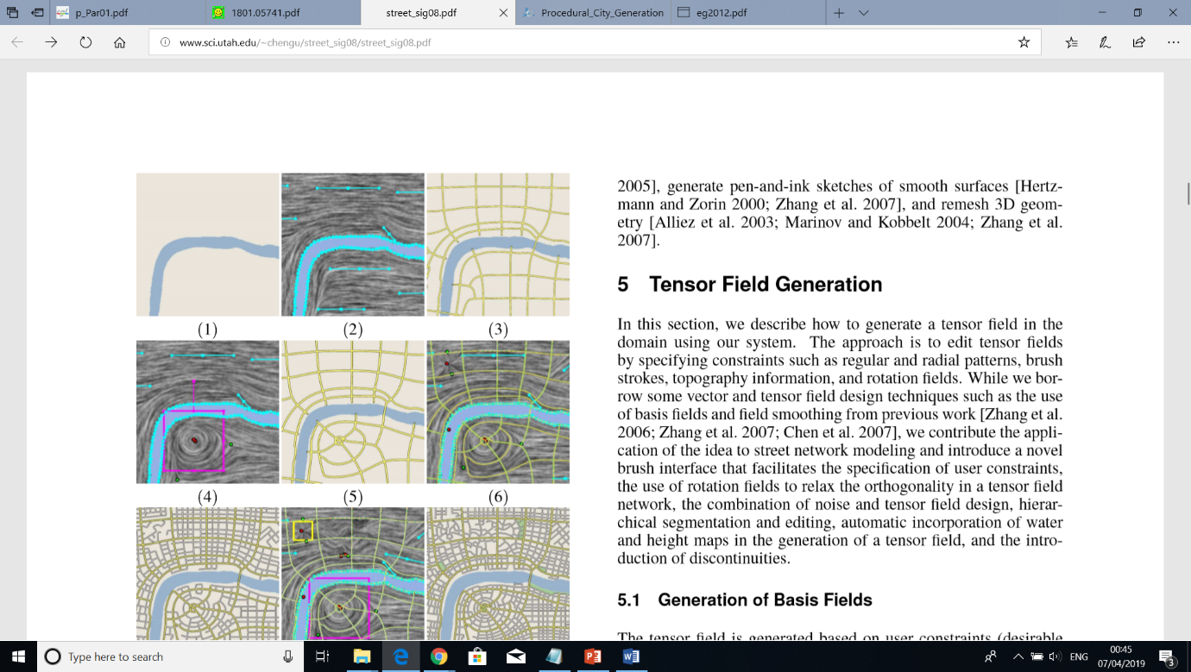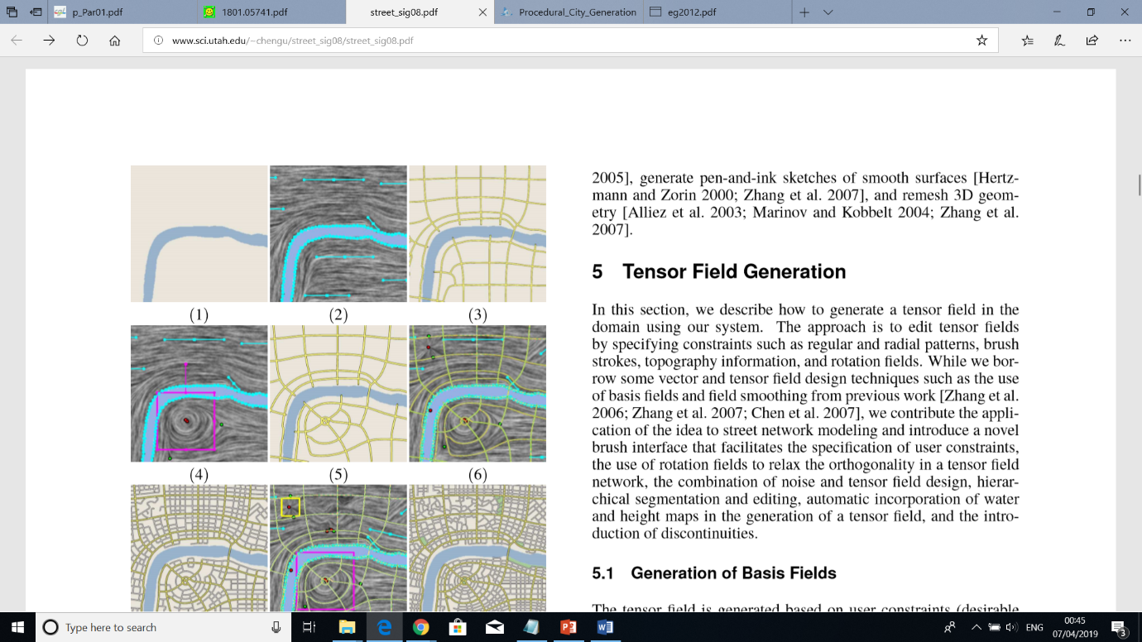

A tensor field is a function that associates every point of typically an Euclidean space with a tensor. In the paper by Chen, each tensor referred to a 2x2 matrix of the form

 where R >= 0 and θ E [0, 2P)

The major eigenvector was { | λ != 0} and the minor { | λ != 0}

However, it should be noted that major and minor eigenvectors are not related to major and minor roads. The different road types have their own instances of both tensor field hyperstreamlines. A detailed explanation can be seen in ?.

### 2.1.3 Voronoi Diagram

Voronoi diagram is another technique that was demonstrated as a way of procedural generation by S. Worley (A Cellular Texture Basis Function) and later found its usefulness in a variety of fields, one being the street network geometry (review, african).

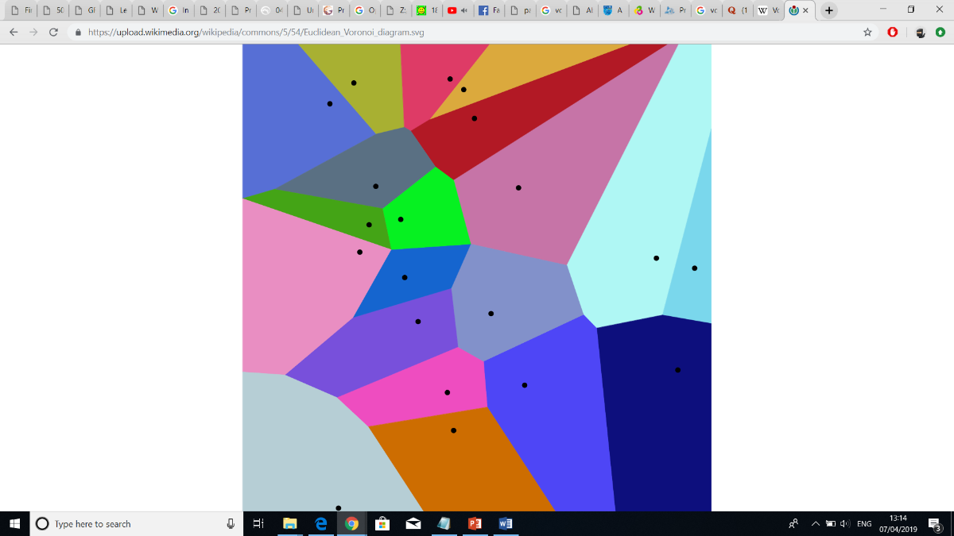It partitions a plane into convex polygons called Voronoi cells based on a set of points called seeds. The partitioning is made in such a way that each polygon contains exactly one seed and the distances between a border and a seed of neighbouring Voronoi cells is the same [Preparata and Shamos 1985]. That way, if a random point is inside a certain Voronoi cell, it will be closer to that polygon’s seed than to any other one.

In the context of procedurally generating street networks, (african) and (the other) interpret the edges of all polygons as streets. (african) even proposed a combined solution where Voronoi was applied to model only major streets and other techniques such as subdivision, Perlin noise and L-Systems generated the minor ones.

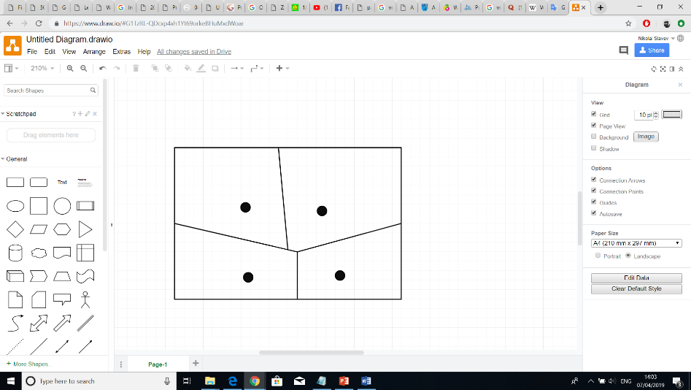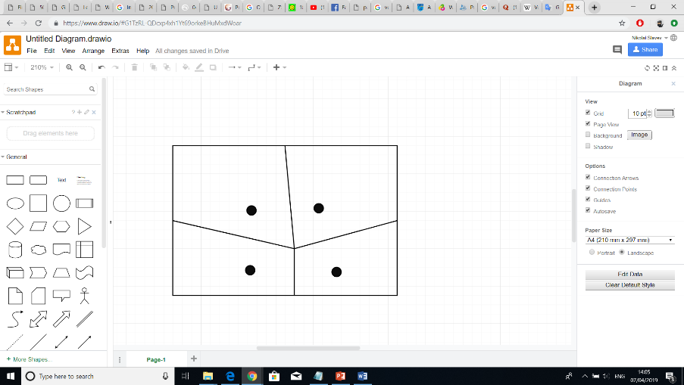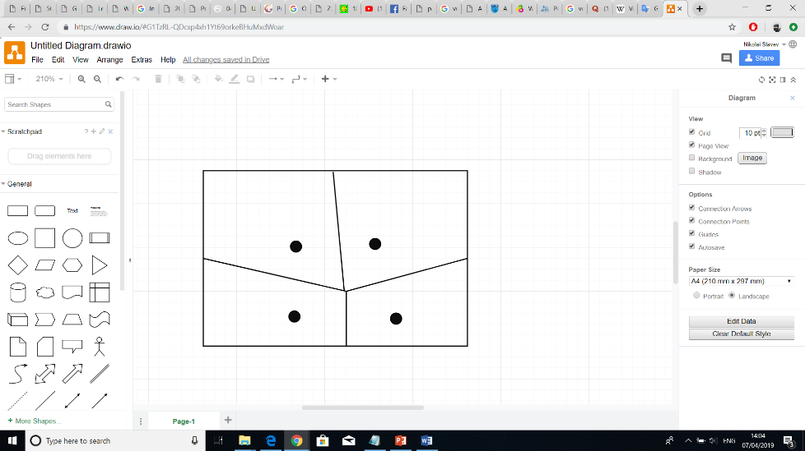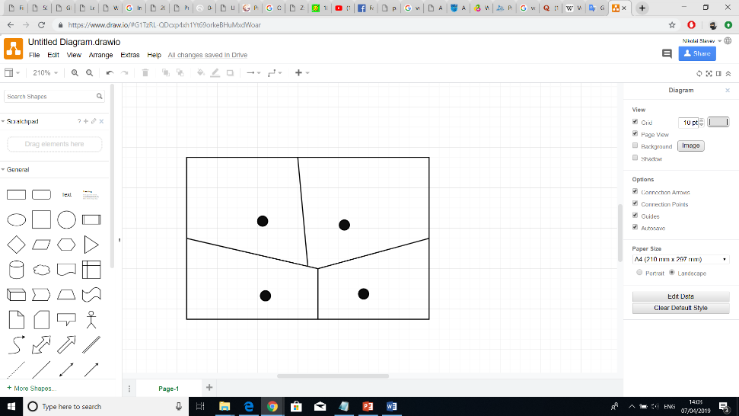An interesting feature of Voronoi diagrams is that if a random point is placed on a cell’s edge, it can have at most three seeds with the same distance to that point. Therefore, a street junction can only join three street segments. Possibilities for mitigating that limitation are to either join together edge intersections that are close to each other or adjust the seeds so that ?

### 2.1.4 Random Planar Graph change with sth else

### 2.1.5 Geographic Data

A recent paper adapted the use of GIS data to create a street network model (geo). The real geographic data consisted of polylines showing the location of each street. Using those polylines as well as information about the street’s type, road surfaces with different width were created. The point where streets join was modelled as a junction object and any fully enclosed areas were treated as building parcels.

The paper, however, aimed at approximating road surfaces (e.g. width, lanes, markings) junction objects (e.g. corner arcs, shape) and building parcel areas as close to the real ones as possible. Using hypothesis and the GIS street data, typical street networks were correctly generated but rare cases failed. Regardless of that limitation, a substantial amount of successfully approximated cases was covered and the rare occasions of unsuccessful hypothesis was easily determined and corrected with editing tools.

Overall, using GIS data as a basis for street generation adds valuable benefits such as:

- realism - the city looks realistic because it is based on a real geographic data

- scale - the size can be large or small, depending on the extracted region

- variation - diverse street variations can be tested and they won’t be unrealistic

proved that

a nice technique for determining the location of streets

tracking the shape and location of the streets

A kinematic rule of thumb attempted to estimate the radius of the corners where streets intersect and form junctions.

first hypothesis – streets were adapted so that vehicles can drive conveniently at a given speed that depends on the street type. Streets tend to drive more slowly on narrow residential streets than on city fast lanes.

second hypothesis – given a speed, a vehicle is limited in the turns it can make. Considering that the vehicle follows an arc of circle trajectory, a radius that is too small would produce a dangerous acceleration and would be uncomfortable. Find the radius r associated with a driving speed s through empirical function f(s) -> r. (SETRA, 2006)

First, we observe that street and urban objects are structured by the street axis

This means that cornerstone in an intersection does not form sharp right turns that would be dangerous for vehicle tires. The most widespread cornerstone path in this case seems to be the arc of a circle, as it is the easiest form to build during public work

Kinematic rule of thumb – attempt to estimate the radius of the corner in the intersection. They give a reasonable best guess result and don’t mean that the streets were made following them

estimate the turning radius based on the assumption that it depends on the type of road.

Then, we use a basic hypothesis and a simple road model to generate more detailed data. We use a widespread street network model, where the skeleton is formed by street axis and intersection forming a network.

Real life streets are extremely complex and diverse; we do not aim at modelling all the possible streets in all their subtleties, but rather aim at modelling typical streets with a reasonable number of parameters.

## 2.2 Streets

Urban street geometry is very diverse encompassing examples of linear, curvilinear and a combination of both streets. To accurately display such diversity in the computer graphics world, however, complex algorithms are required. This subsection will reveal the possible approaches of rendering street examples as well as techniques for turning street lines into larger segments and later tessellating them.

### 2.1 Street Axis

A computer graphics solution to finding the trajectory of lines whether curved or straight is by using Bezier curves. Such curves are defined by a set of control points P0 through Pn where the first and last points correspond to the start and end points of the curve. From that follow that:

when n=1, the curve is linear

when n=2, the curve is quadratic

when n=3, the curve is cubic

Furthermore, a combination of multiple Bezier curves can be joined together to form a Bezier spline. If that spline follows certain properties like smoothness and identical curvature at the breakpoints, it gets called a B-Spline.

The linear Bezier equation simply defines a straight line between two points as follows:

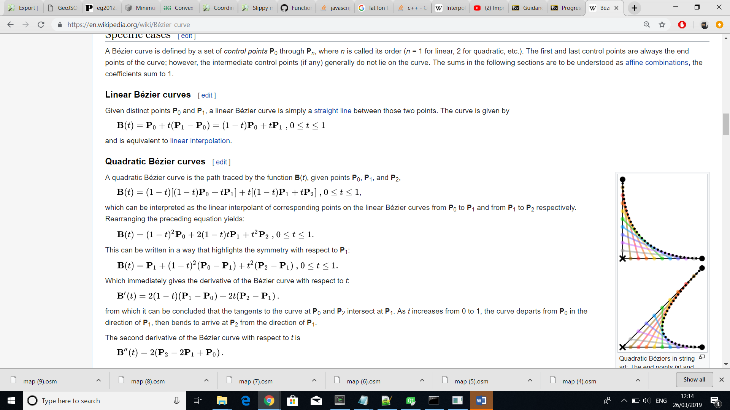

where B(t) gives the path between P0 and P1 depending on the value of t.



The quadratic equation uses three points P0, P1 and P2



but can also be interpreted as three linear interpolations from P0 to P1, P1 to P2 and then the resulting point from the first equation with the resulting point from the second.

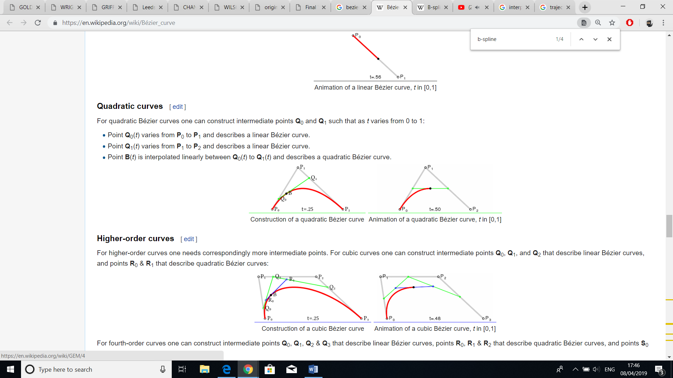

A cubic Bezier curve is defined in a similar way except that four points are used.

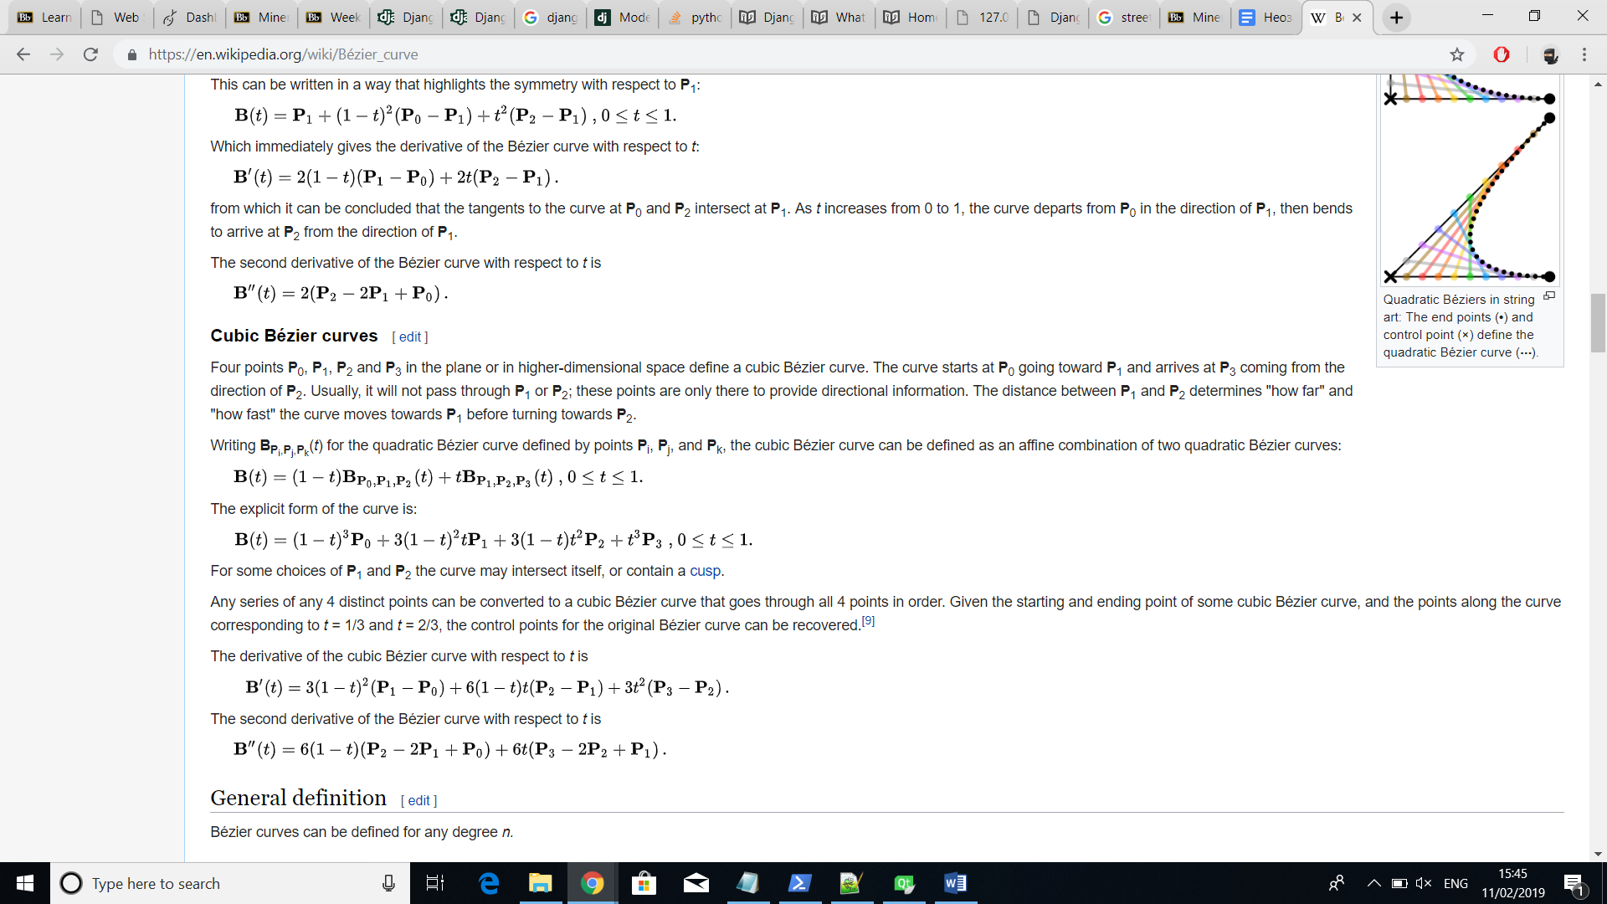

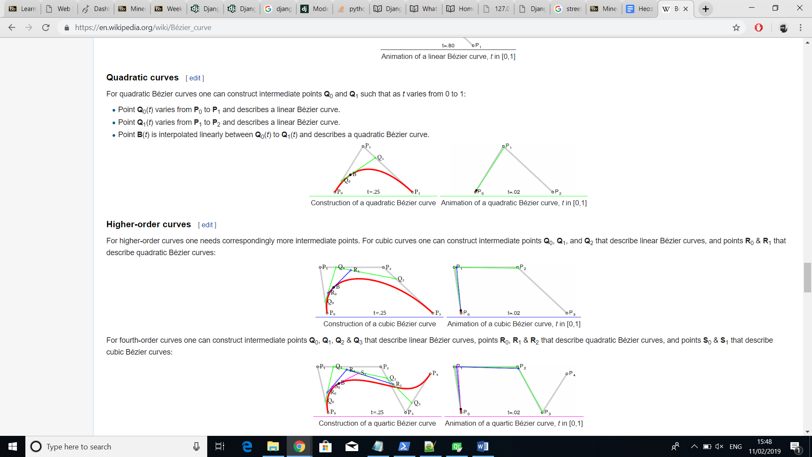

B-Spline

…

### 2.2 Street Segments

Using Bezier curves enable the creation of diverse lines in computer graphics but a single line is not sufficient to represent a complete street. The algorithms regarding computation of street networks only determine the middle line of the street also called street axis. What we are after, however, is a street not only with length but also with width. (there is better expln)

Turning a straight line into a rectangle is simple. Start and end points can be offset by a predefined amount using the direction of both clockwise and counter-clockwise normal unit vectors. Then, tessellating the object as a polygon using the four new points.

Curved streets, on the other hand, would consume more computational power since offsetting them requires more such iterations and finding the normal vectors is not as straightforward. For each point, that has been found while either computing the quadratic or cubic Bezier equation, the tangent of that point needs to be computed. Based on the tangent, both normal vectors can be found. Doing that for all points and simultaneously summing each normal vector with its corresponding point will give the contour of the curved street segment.

(curve pictures with normal and tangents)

However, in case of a really small curve axis the inner offset curve would intercept itself causing the street segment to fail. (how to fix).

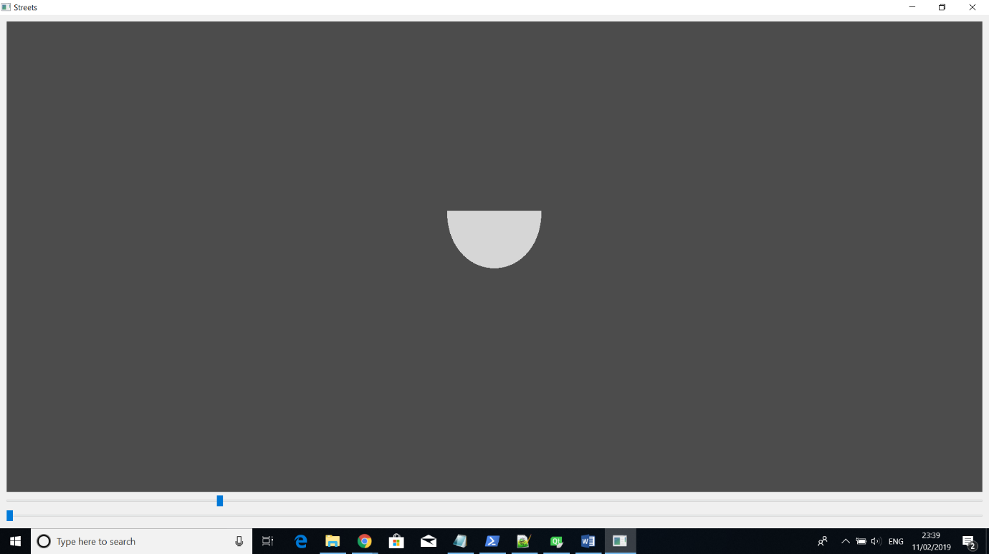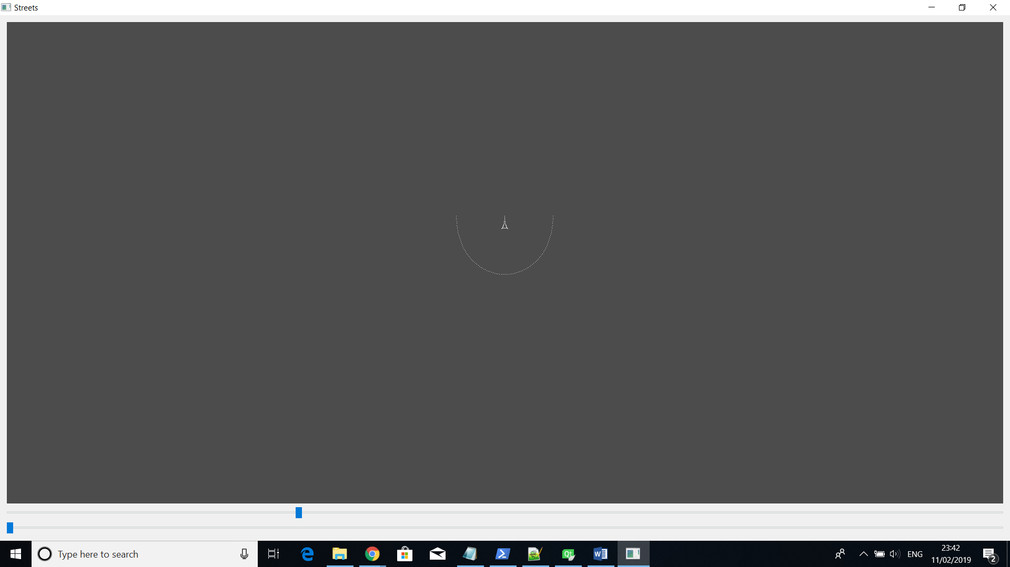

Tessellating …

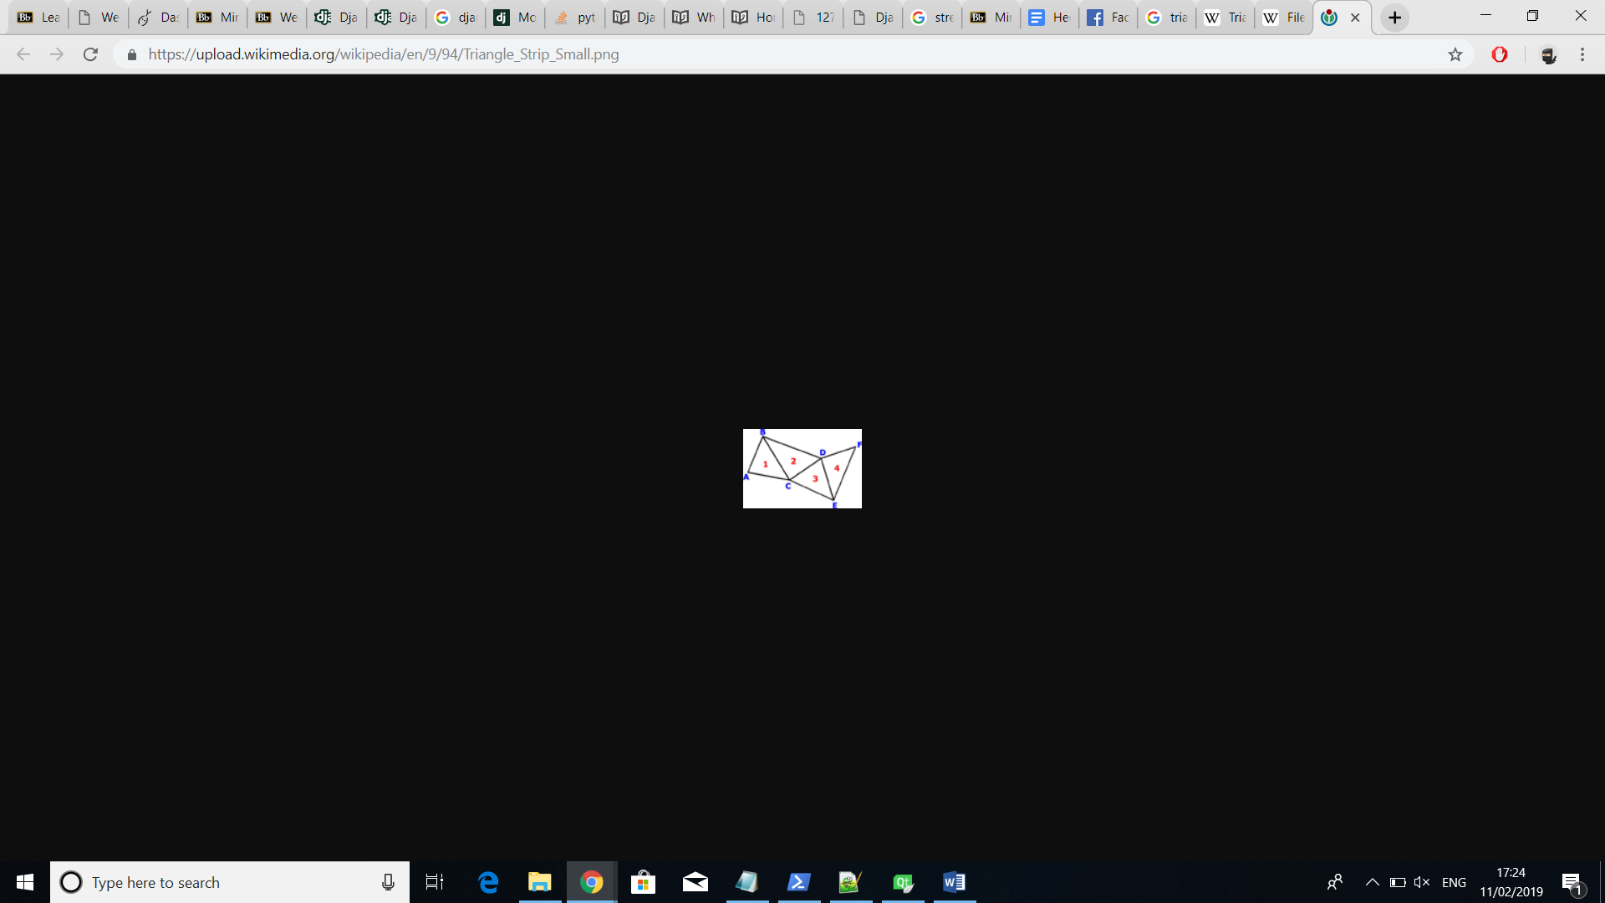

Four points can define a cubic Bezier curve – P0, P1, P2, P3. The curve starts at P0 and ends at P3. The other two points provide directional information and they don’t get intersected by the curve. The distance between them (P1 and P2) also determine “how far” and “how fast” the curve moves towards P1 before turning towards P2*

After defining a street network in the form of a graph consisting of nodes and edges, each edge can act as the axis of an individual street segment. Those segments can have different width depending on the street type. However, offsetting the edge axis on both sides to resemble a street requires the finding of offset directions and length.

However, the focus is clearly to reconstruct road and not streets. Streets are much more complex objects than roads, as they express the complexity of a city, and contains urban objects, places, temporary structures(like a marketplace). [junctions]

The aim may also be to create a road network as the base layout of a city. Indeed, stemming from the seminal work of Parish and Muller (2001), a whole family of methods ﬁrst creates a road network procedurally, then creates parcels and extrudes these to create a virtual city. These methods are very powerful and expressive, but they may be difﬁcult to control (that is, to adapt the method to get the desired result). [junctions]

Real life streets are extremely complex and diverse; we do not aim at modelling all the possible streets in all their subtleties, but rather aim at modelling typical streets with a reasonable number of parameters.[junctions]

## 2.3 Junctions

### 2.3.1 Computation of arcs

discuss the two cases of curves

### 2.3.2 Computation of surfaces from arcs

say that the streets are cut

## 2.4 Building Parcels

2.4.1 Finding parcels

2.4.2 Subdividing parcels

make two subsections - finding the whole parcel and subdividing it

What follows after road map generation is allocation of building’s space. Small areas surrounded by streets act as spaces called blocks which we assume that can be inhabited.

These spaces get divided into smaller convex or rectangular shapes called lots representing the space for a single building. To achieve that, a recursive algorithm divides the longest edges that are approximately parallel to each other until the lots reach a size limit threshold. There exist other techniques for dividing blocks into lots but generally city regulations need to be taken into account when such algorithms are implemented. For example, all lots need to have direct access to a street and shouldn’t be too small. If that occurs, these shapes are discarded from the system.

## 2.6 Buildings

briefly say what we do -> not sure if it is necessary

For every allocated space a building can be generated. These buildings are again procedurally generated but follow a different L-system parametric approach which can only apply to a single building type. Therefore, for every type, whether skyscraper, commercial or residential, a different set of production rules are applied.

To allow for an automatic level-of-detail model creation, a restricted ‘decreasing apices’ L-system class as described in [14] can be used. Since the generation of the building starts with its bounding box as the axiom, the output of each iteration can be interpreted as a refining step of the geometry. The output of the L-system is fed to another parser, which translates the resulting string into geometry readable by the visualization systems.

## 2.7 Algorithms evaluation and decision

GIS for input because it supports well scalability, realism, and ?

The most recent paper to be evaluated although the aim was to accurately construct the streets considering width and turning radius

linear, quadratic and cubic Bezier curves

linear will be used for most cases

quadratic can be used for the turning radius because it’s easier to find one control point than two

cubic will be used for normal curved streets because it is a necessary step in case B-Spline will be implemented. Also, I have noticed that the GIS data implements a simple curve using at least 3 polylines which means that the curve will be made of 4 points (start, end and 2 control points).

the turning radius will be calculated using curves and not circles because curves will be already adapted for use on the software and using the circle solution would delay any additional developments due to the time restriction. Also, circles don’t add much benefit over curves.

finding the large building parcels ?

dividing the large building parcels into smaller lots can be made using the division of the minimum bounding boxes because ? no idea

# Chapter 3 Project Methodology and Planning

# Chapter 4 Implementation

This chapter will give thorough explanation of the design and development approaches. It will, firstly, discuss the technologies, user interface and code architecture before moving to explanations of how the project’s objectives were met.

## 4.1 Technologies Used

The software was written in C++ using Qt Creator as an IDE and OpenGL as a graphics rendering API. Other supporting technologies were OpenStreetMap, ReadOSM and SketchFab.

The decision to use C++ in conjunction with Qt Creator and OpenGL was primarily influenced by the Computer Graphics module as it substantially covered the foundations of graphics development and rendering using those technologies. Compared to other alternatives, the mentioned choices have significant advantages. Using C++, for example, developers can benefit from memory management, extensive graphics libraries, large graphics literature with supporting community and diverse opportunities for computational speed improvements. QT Creator, on the other hand, facilitates the coding process providing cross-platform support that includes compiler and debugger programs - MSVC and CDB in our case. It is a popular choice by many graphics developers and has a massive community base.

In addition to the main technologies, others were required to ensure completeness of the project. Due to the decision of using geographic data as a street network input, a set of software solutions were needed to provide and parse the data. OpenStreetMap had the ? and was used for exporting selected map regions. Then, a lightweight library called ReadOSM was used to parse and structure the exported OSM file.

SketchFab – website which displays an obj file

(probably don’t need to mention sketchfab as it is not required and any other 3D editor can be used?)

## 4.2 User Interface

In the computer graphics world, visualisation is crucial as it best communicates the idea and outcome of a product. The developed software, therefore, not only emphasised on technically correct but also on visually appealing and interactive imagery. To accomplish that, the user interface included a large visualisation screen as well as possibilities for extensive camera control, scene editing and scene simplification.

A large screen was included because it is a necessity in every visualisation especially when the model displayed has the scale of a city (refer to the picture). Camera control, on the other hand, can assist the presentation by showing it from different angles. The project made use of the arrows to move user’s viewing angle forward and backward as well as rotate it left and right. QKeyEvent was used to detect keyboard press events and alter the current camera properties whereas gluLookAt was used to position the camera with respect to the changed values. In addition, moving and rotating the camera up or down was enabled through two vertical sliders from the QSlider library.

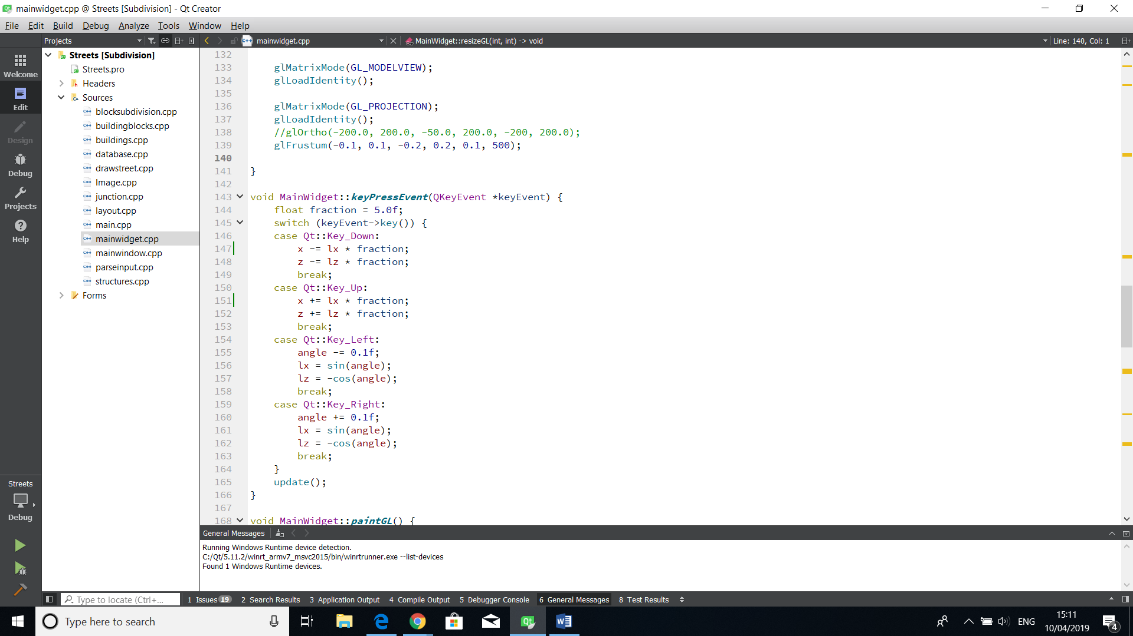

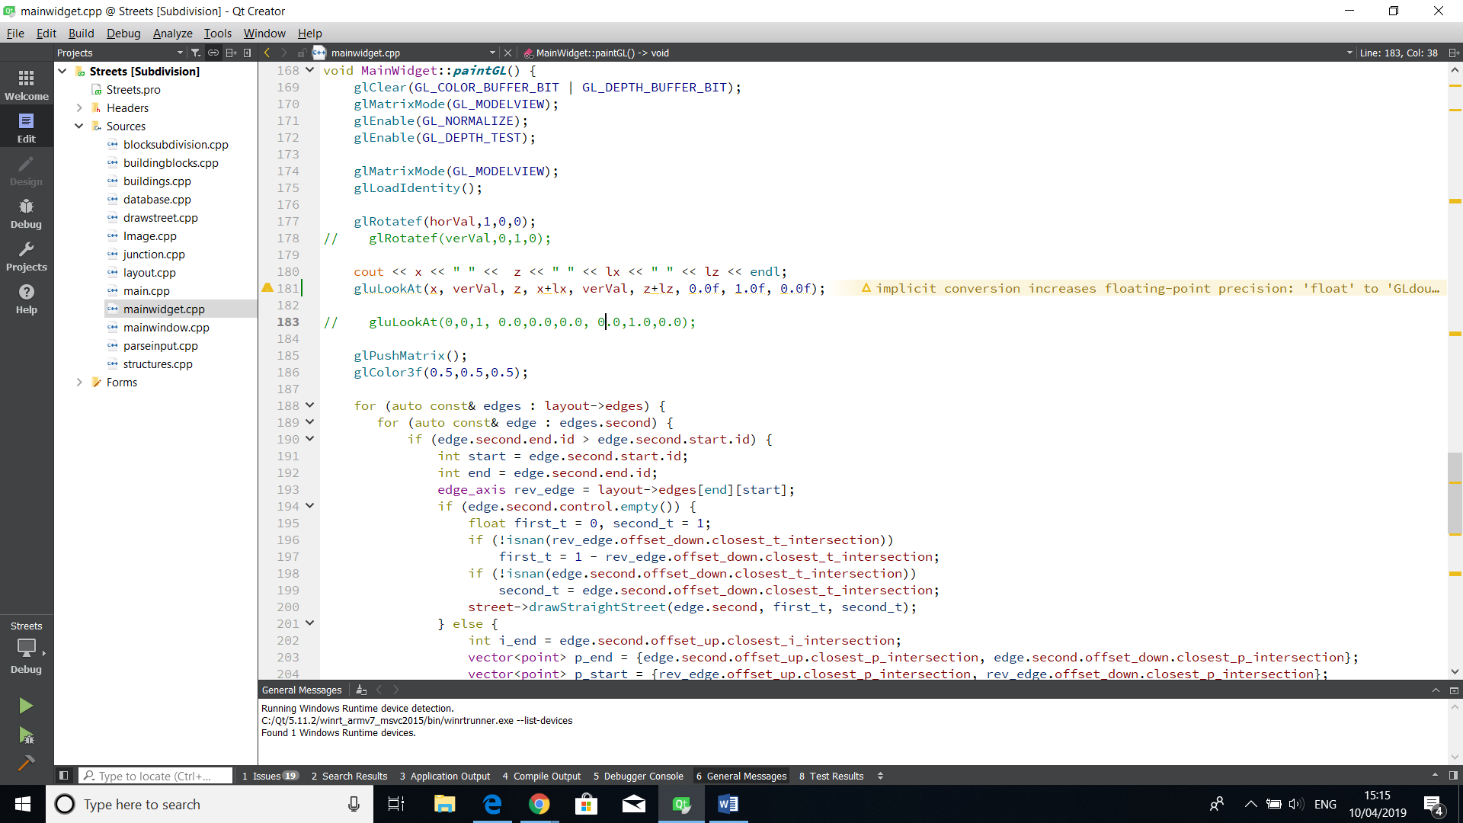

(arrows picture) (picture of the axis x,y,z and then can show how the camera rotates)

(pictures from different angles FPS, from higher)

Occasionally, users might prefer a more simplistic scene especially when the city gets too cluttered with buildings that obfuscate the street geometries. In such cases, changing the camera’s positioning might not be sufficient. For that reason, the interface includes a checkbox option for enabling and disabling building geometries.

(picture of on and off buildings)

Exporting the final model as a mesh is also a supported option. The model can be stored in a file with a standard 3D image format called OBJ which would contain a collection of polygon faces with vertices and edges. User can, then, open the file in their preferred 3D image editing program such as Blender, Maya or SketchFab and interact with the model even further.

(picture from sketchfab + the obj file)

The last feature of the interactive user interface is a real-time editing option which aims at giving users the opportunity to adjust the street network to their desires and expectations. However, the project’s plan intentionally didn’t allocate much time to this additional feature as it would deviate the project from its main objectives. Nevertheless, the editing can be applied to the points where streets join (i.e. the junctions) and would execute smoothly on a scale comprised of up to ? nodes. The functionality is enabled through a text box, which input determines the point to be edited, and two vertical sliders, which can move the selected point on the x or z axis. Movement of any of the two sliders would trigger an event which would move the selected point accordingly and reconstruct every object that has direct connection to it.

(multiple pictures of how the node is moving (with and without buildings))

(picture of the whole interface)

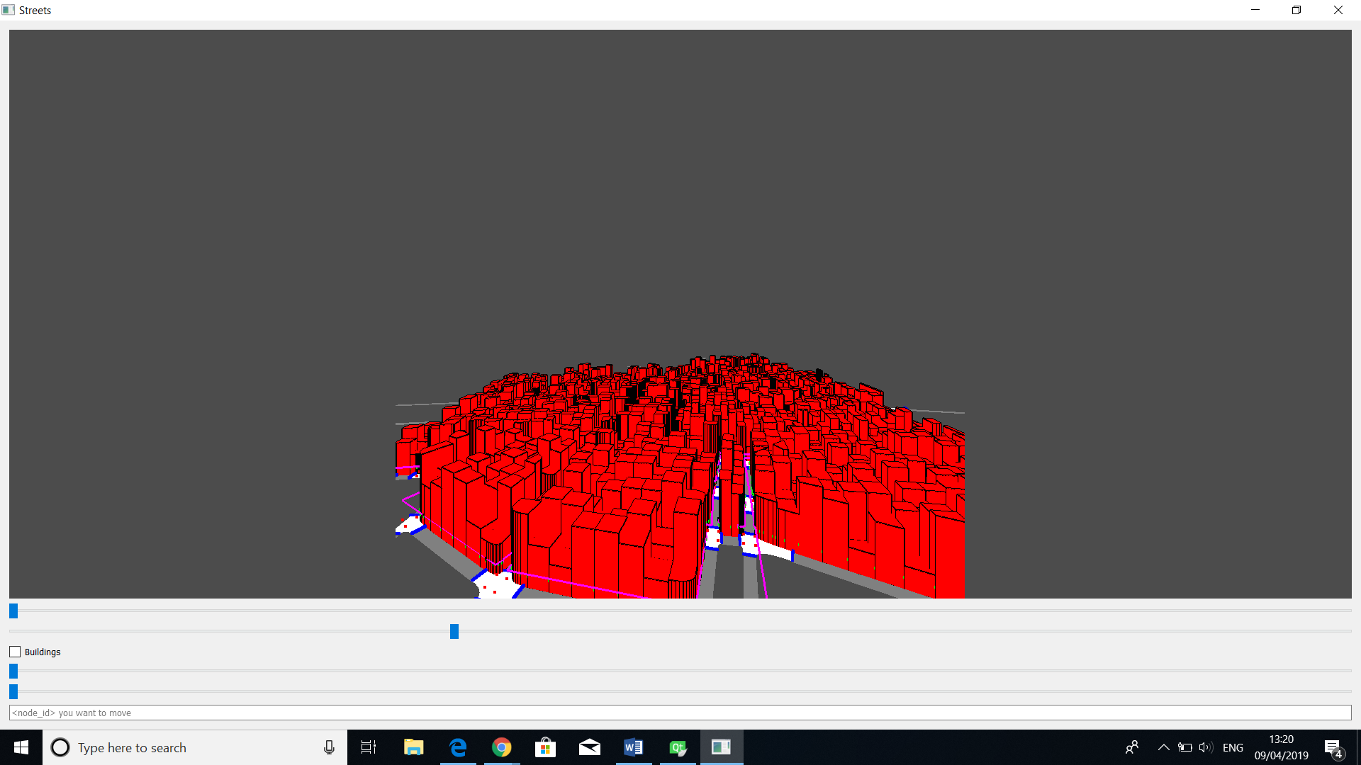

## 4.3 Code Structure and Workflow

This section focuses on the project’s software structure that formed a complete coherent system. Firstly, it will describe a high-level software workflow of the system and in subsections individually cover coding implementations of the chosen algorithms from (*Section 2*).

The high-level software workflow is depicted on *(Picture 1)* and shows the tasks the software performs to build a 3D city model. Note that steps (1, 2, 3) are only needed if a map has not been extracted yet or the user wants to change it. Furthermore, steps (5, 6) are optional and can be followed if a user wants to load the model into a 3D editor.

Assuming that the full workflow will be followed, the steps are as follows:

• Since the software bases its street network on a real geographic layout, the first step is to extract a geographic area from a map provider such as OpenStreetMap.

• To make that data understandable/assimilable? and omit unnecessary details, a parser needs to convert it. In our case, the extracted data is in OSM file format and gets converted to CSV.

• Then, the data can be inputted into the Main program that models and visualises the procedural city using appropriate techniques discussed in (*Section 2).*

• Lastly, the model can be exported as an OBJ and visualised into a 3D editor such as Blender, Maya and SketchFab.

(progressive images of how the city is developed)









### 4.3.1 Street Network Layout

As discussed in the overall structure, the first step of modelling a city is through extracting and parsing a region of a real geographic map. The implementation of this approach will be discussed in (Section 4.3.1.1) then (Section 4.3.1.2) will describe how the resulting output can be visualised in OpenGL.

#### 4.3.1.1 GIS Parsing

A region from the world’s map can be exported into a file using a software called OpenStreetMap as shown on (*Picture 1*). The file would have an OSM format that follows XML syntax (*Picture 2*) and would contain information about objects encompassed in the form of XML tags. For example, a certain object would be defined by a tag called “way” which would contain multiple other tags like “nd” and “tag”. The latter keeps the name of the object’s type that “way” defines (e.g. street, building, park, pond, etc.) whereas the former keeps a reference to another tag called “node” (*Picture 2*). A single “node” stores information about the location in latitude and longitude of a single point on a map. A “way” tag would, therefore, only include “node” tags that are part of the contour of the object that “way” refers to.

Knowing about the OSM file structure is important but it cannot be easily traversed by programming languages as it is. A parser containing formal grammar that is specifically designed for such files can extract and pass the meaningful information to a specific programming language. The project, therefore, makes use of a lightweight parser called ReadOSM in order to use the OSM information in C++.

Filtering and adapting the information provided was also required. Firstly, the project needed only tags that define streets, everything else had to be discarded. Then, streets had to be adapted to end when they intersect with another street, resembling a network. Furthermore, curved streets were not supported and were represented by multiple straight lines. Lastly, the locations were in latitude and longitude and had to be converted to pixel coordinates. All those concerns were resolved in the class ParseGIS (*Picture 3*).

• parseNode() and parseWay() used ReadOSM to find “node” and “way” tags which information was then stored in the variables nodes and ways. Any “way” tag that did not define a street and any “node” that was not part of a street got filtered out.

• divideWay()

• convertCoordinates()

• convertCurve()

three problems: includes a lot of information we are not interested in; streets cross each other, they don’t end when they cross each other; curved streets are still made of polylines and we want smoother curves; the location is expressed in lat/lon and we need pixel coordinates

division of ways

turning ways into curves

stripping the data of irrelevant information and keeping only the way tags that represent streets. Also, keeping only the nodes that are included in the streets

approximating the lat, lon coordinates to pixel coordinates



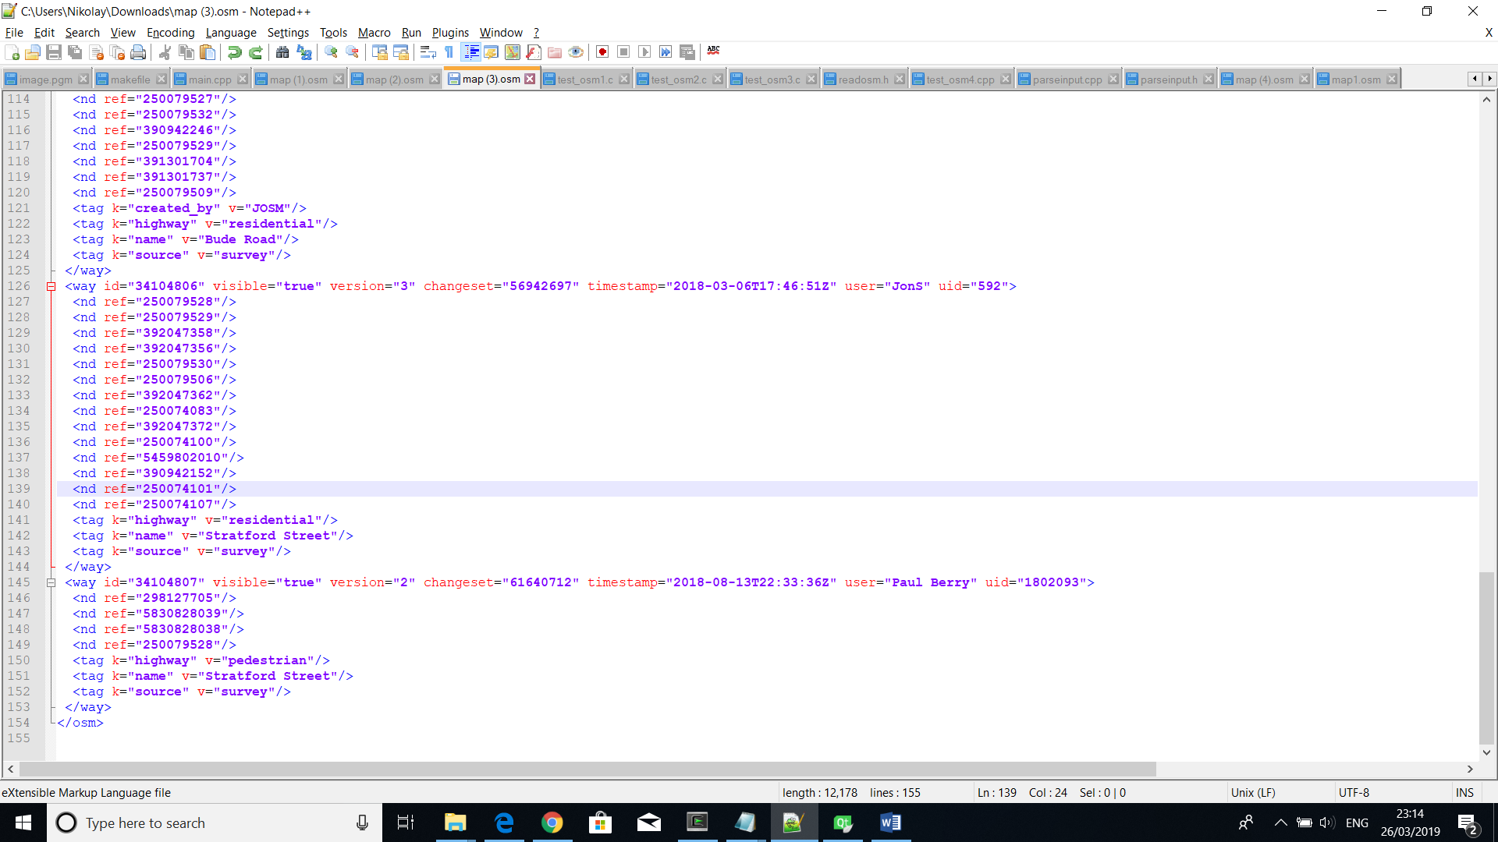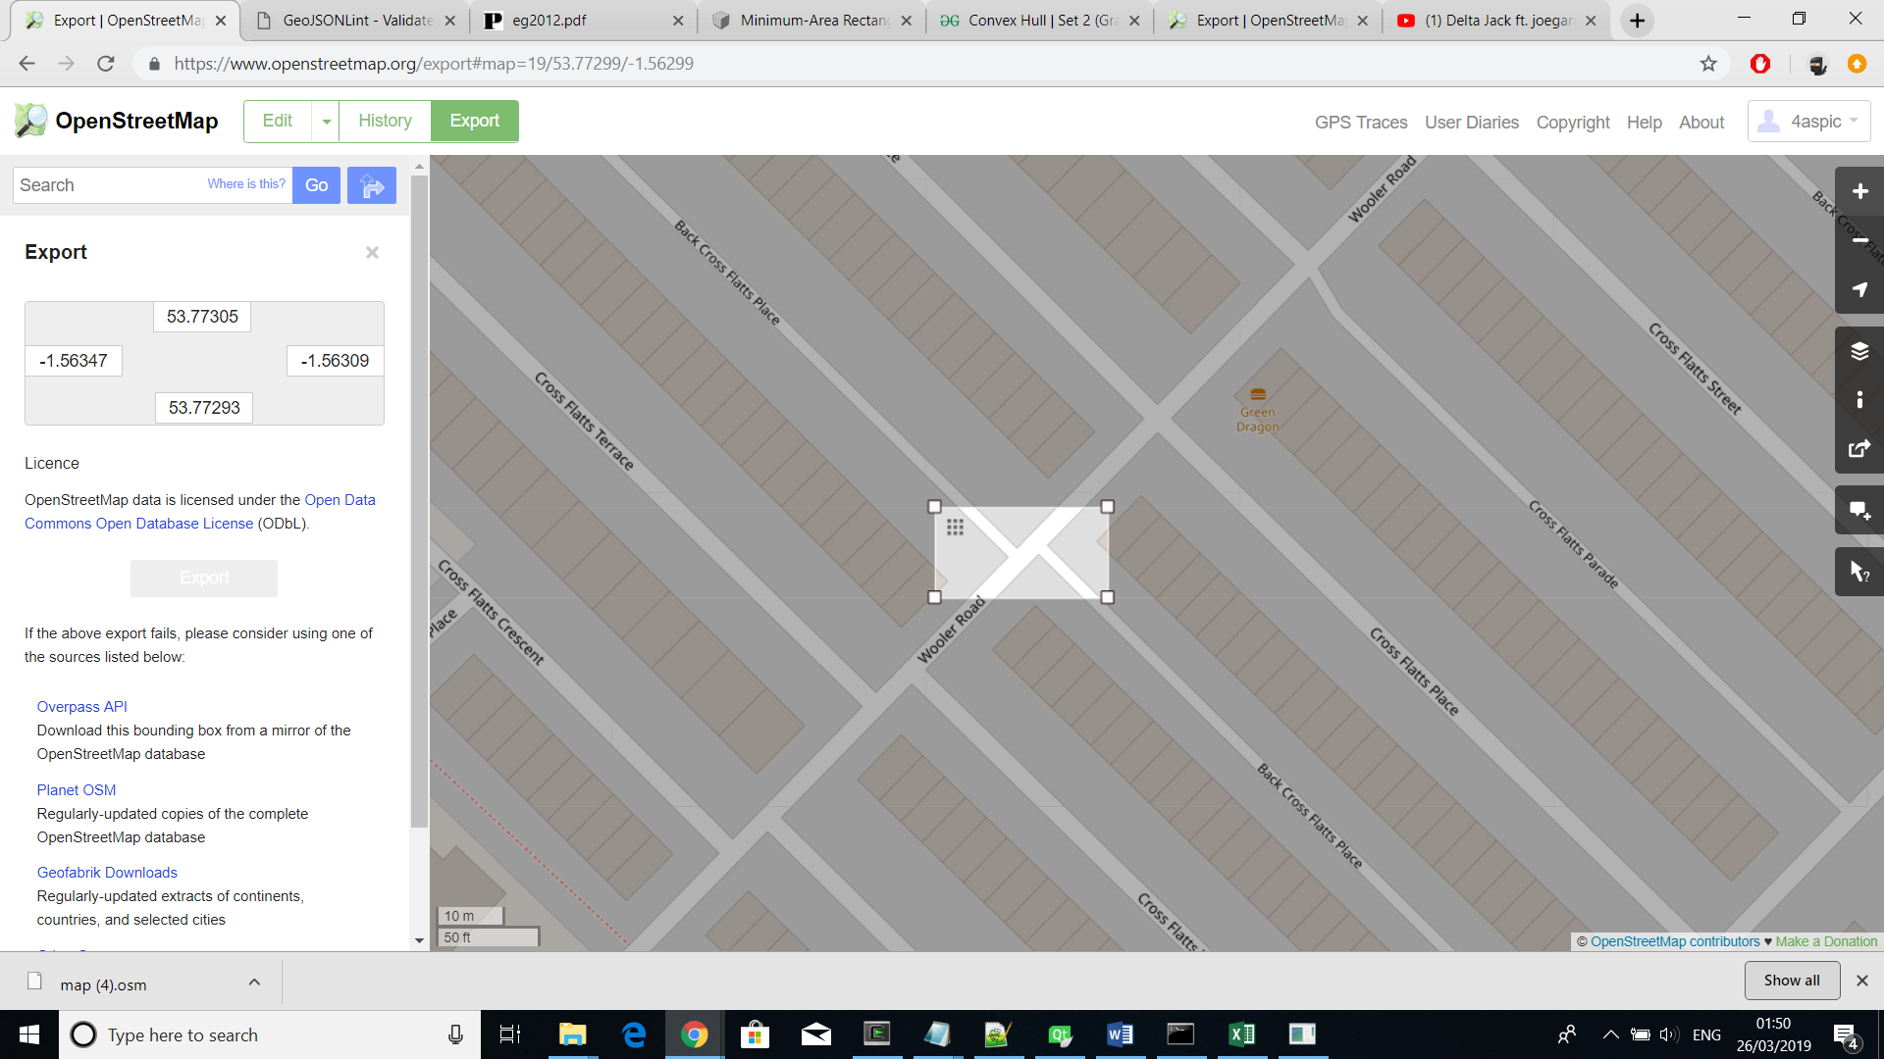

export parse

🡪 🡪

OpenStreetMap OSM File CSV File

#### 4.3.1.2 Layout implementation

the layout -> nodes and edges with the structures



🡪 the streets but only lines

### 4.3.2 Street Network Segments

#### 4.3.2.1 Streets

the offset structures and that we use the equation for Bezier curves with the combination of offsetting the line using its normal vector (all referenced)

that the triangle strip is used to make it as a segment

#### 4.3.2.2 Junctions

each node is a junction (where the edges/streets join)

explanation of how the pairs were found -> using the finding of loops

how the curve was found??

how the segment was found/traced

how the streets were cut -> considering the t

where the junctions were storred

### 4.3.3 Buildings

#### 4.3.3.1 Building Parcels

use the loop algorithm

then consider the segments -> don’t know how

when converting to segments the order of points needs to be correct

#### 4.3.3.2 Building Lots

#### 4.3.3.3 Building Objects

the building objects are forming the shape of the building lot and get assigned random height

how are the lots made into objects with height -> describe short

a diagram showing how the classes are linked

extract map -> parse map -> store structured data in new file

main file -> main widget + other widgets for user control

main widget -> creates the layout (using the new file) -> offsets the streets -> finds the junctions -> finds the building parcels with respect to the new street objects and junctions -> subdivides the parcels -> finds the buildings -> paints everything -> export obj (optional)

sets the camera?; pairs

making the layout – GIS + nodes, edges..

making segments – subsections for streets and junctions

buildings –

couple of pictures showing the design – starting from layout then only streets then with junctions …

4.4 GIS data

exporting + parsing the data + writing to file

4.5 (can be merged with the offsetting of the streets or in different smaller subsections)

making the layout -> use of structures to represent nodes and edges

4.6

offsetting the streets -> use of another structure for adding offset streets

4.7

finding the building parcels without considering overlapping

based on that assign pars for the junction objects and find the intersection points

find the closest intersection point and cut the corresponding streets

find the turning radiuses and store the junction object

4.8 (put before the junctions and at the end of the junctions say that building parcels area can now be updated considering the overlapping objects)

when the objects are found start considering the overlapping objects for the building parcels

4.9

subdivide the parcels

4.10

do the buildings

implementation should be largest - do everything there

if something needs to go to the background research it will be a small part only

in the format

node

…

node

node_id node_id

node_id node_id

converting polylines to street axis - straight and curved

nodes are added as nodes and the combination of nodes as edges

why C++, QT and OpenGL

interface?

input – GIS data + readOSM to parse it and remove unnecessary data + r-ead from the new file

# Chapter 5 Testing

# Chapter 6 Results

# List of References

Graphics.ethz.ch. (2019). [online] Available at: <https://graphics.ethz.ch/Downloads/Publications/Papers/2001/p_Par01.pdf> [Accessed 17 Jan. 2019].

Citeseerx.ist.psu.edu. (2019). [online] Available at: <http://citeseerx.ist.psu.edu/viewdoc/download?doi=10.1.1.88.7296&rep=rep1&type=pdf> [Accessed 17 Jan. 2019].

Citygen.net. (2019). [online] Available at: <http://www.citygen.net/files/Procedural_City_Generation_Survey.pdf> [Accessed 17 Jan. 2019].

Sci.utah.edu. (2019). [online] Available at: <http://www.sci.utah.edu/~chengu/street_sig08/street_sig08.pdf> [Accessed 17 Jan. 2019].

Arxiv.org. (2019). [online] Available at: <https://arxiv.org/pdf/1801.05741.pdf> [Accessed 17 Jan. 2019].

Pdfs.semanticscholar.org. (2019). [online] Available at: <https://pdfs.semanticscholar.org/04f0/44da13e618ca8b399f004e713603e54e17cb.pdf> [Accessed 17 Jan. 2019].

<https://www.researchgate.net/publication/229707505_Procedural_Generation_of_Roads>

<https://www.researchgate.net/publication/220183520_Interactive_Procedural_Street_Modeling>

<https://www.researchgate.net/publication/260335265_Procedural_Modelling_of_Urban_Road_Networks>

<https://www.isprs-ann-photogramm-remote-sens-spatial-inf-sci.net/II-3-W5/409/2015/isprsannals-II-3-W5-409-2015.pdf>

<http://peterwonka.net/Publications/pdfs/2011.EG.Lipp.CityControl.final.pdf>

<http://citeseerx.ist.psu.edu/viewdoc/download?doi=10.1.1.88.7296&rep=rep1&type=pdf>

<http://hpcg.purdue.edu/papers/Benes11I3D.pdf>

Operational Urban Models State of the Art, M Wegner, <https://www.tandfonline.com/doi/abs/10.1080/01944369408975547>

<https://www.cs.williams.edu/~morgan/cs371-f12/gallery/5-Midterm/manhattan.pdf>

<https://www.researchgate.net/figure/From-left-to-right-A-scheme-of-L-system-6-its-application-to-the-simulation-of-algae_fig1_326251916> (tree)

<https://phiresky.github.io/procedural-cities/presentation.html#/highway-branching> (extended L-system pictures)

<http://www.cs.ru.ac.za/research/groups/vrsig/pastprojects/047proceduralmodelling/paper09.pdf> (voronoi)

# Appendix A External Materials

<Level 1 Heading with ‘heading 1’ Style Applied by Pressing Ctrl Shift 1> Text under appendix heading. Text under appendix heading. Text under appendix heading. Text under appendix heading. Text under appendix heading. Text under appendix heading.

## A.1 Level 2 Heading with ‘heading 2’ Style Applied by Pressing Ctrl Shift 2

Text under level 2 heading. Text under level 2 heading. Text under level 2 heading. Text under level 2 heading.

### A.1.1 Level 3 Heading with ‘heading 3’ Style Applied by Pressing Ctrl Shift 3

Text under level 3 heading. Text under level 3 heading. Text under level 3 heading. Text under level 3 heading.

#### A.1.1.1 Level 4 Heading with ‘heading 4’ Style Applied by Pressing Ctrl Shift 4

Text under level 4 heading. Text under level 4 heading. Text under level 4 heading. Text under level 4 heading.